SQL ASSIGNMENT 5

RELATIONAL AND LOGICAL OPERATORS

Q1. Write a query that will give you all orders for more than Rs.1,000.
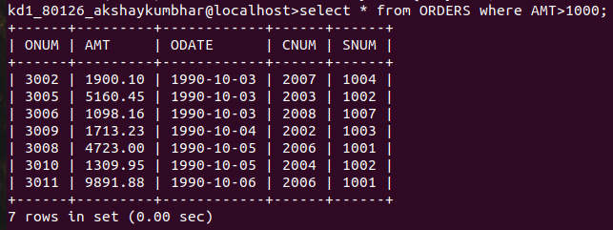
Ans.

Q2.Write a query that will give you the names and cities of all salespeople in London with a commission above .10.
Ans.

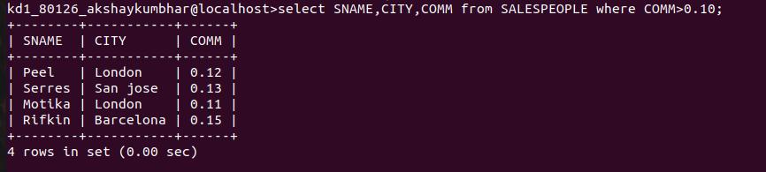

Q3.Write a query on the Customers table whose output will exclude all customers with a
rating<= 100, unless they are located in Rome.
Ans.

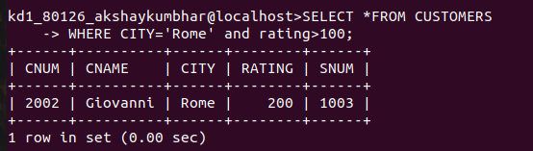

Q4.What will be the output from the following query:

Ans.select * from orders
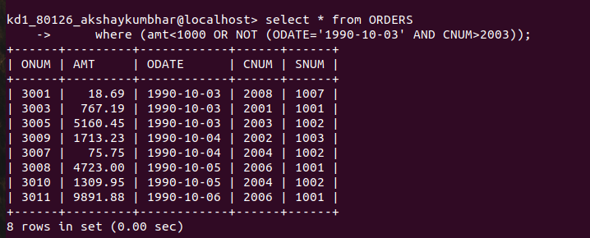
where (amt < 1000 OR
NOT (odate = ‘1990-10-03’
AND cnum > 2003));

Q5. What will be output of the following query?
Select * from orders
where NOT ((odate = ‘1990-10-03’ OR snum
> 1006) AND amt>= 1500);

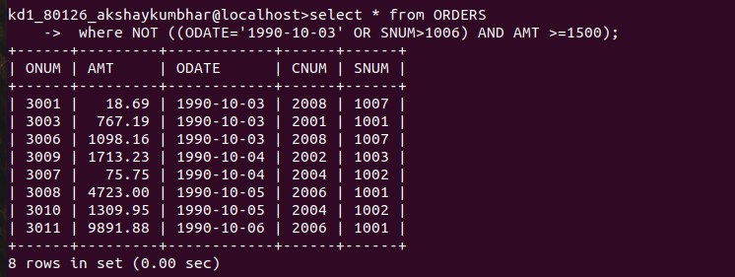

Q6.What is a simpler way to write this query?
Select snum,city,comm from Salespeople where comm > 0.12 OR comm 0.14;

Ans.

